Are You Naked Online?
VPN Questions Answered

by Robert Thompson and Winton Churchill

If you do not use a Virtual Private Network (VPN) for international freelancing, you may find yourself exposed.
Early on, my journey as a traveling freelancer taught me the value of a VPN. We sailed my boat to its new home in Panama, stopping at many different countries along the way.
Then “the email” struck. My freelance platform wanted to validate my location because I kept connecting from different locations. Clearly, you need to have a secure connection to your base country to make a good impression on Upwork and your clients.
On the same trip, my access from the marina to some critical sites was blocked. In particular, I couldn’t share large files because I couldn’t get access to file sharing sites. This caused a problem when sharing information with my client! Using a VPN let me access the site and share files securely.
If you are new to using a VPN, here are some answers to common questions to get started.

Q. What is a VPN?
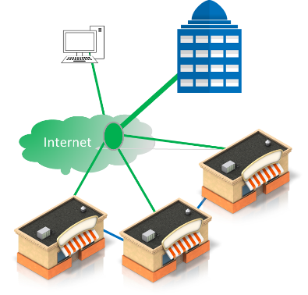
A VPN is a secure connection across the internet to a server in another location.
It’s called a Virtual Private Network because it replaced expensive “Private Networks” that connected company offices using leased phone lines.
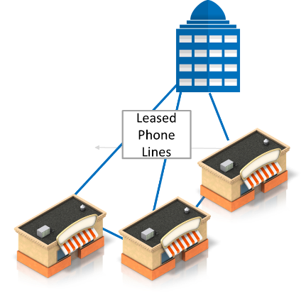
.

Q. How does a VPN work?
Without a VPN
To understand how a VPN works, you first need to know how you connect without a VPN. Here, you access the internet directly. The connection is often not secure and can be monitored, particularly on WIFI.
Also, you’re assigned an internet address by your ISP. The internet wasn’t designed to associate your location to your address. However, some companies sell a tool that maps Internet addresses to a location.
This information is often inaccurate, but that doesn't stop them from selling the information to companies like Upwork.

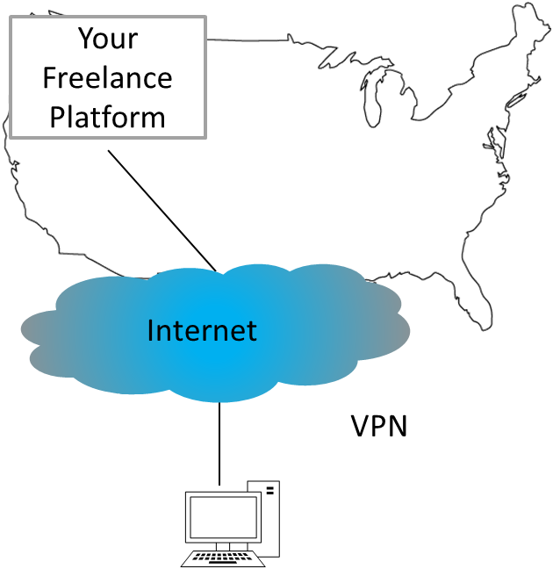
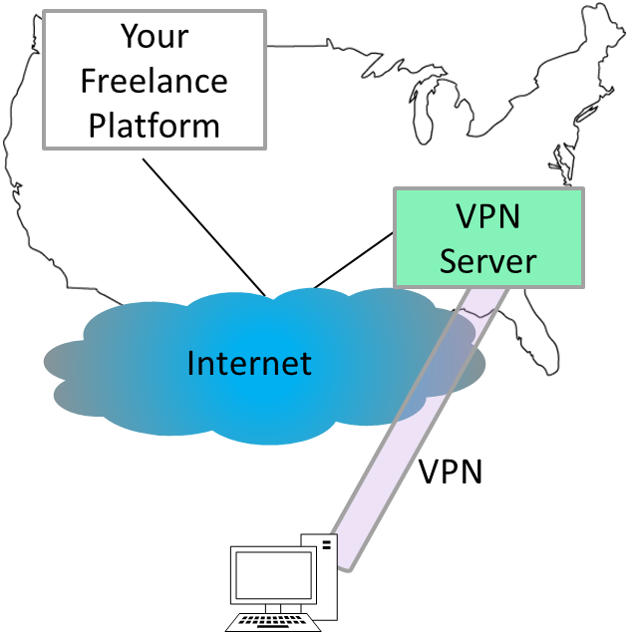
A VPN makes a secure tunnel from your PC to a VPN server. An App connects to the tunnel and then sends your communications through the tunnel. That VPN server then connects you to the internet from their location. Most commercial VPN service providers allow you to choose the country/city you connect to, and you then work from that location
.

Q. Why do people use VPNs?
Most people use a VPN because it provides a secure connection to the internet. All of the work you do is encrypted. Your local ISP can’t monitor what you’re doing, or block your access to US sites. You’re still connected to the internet, but that connection is from a secure location in your home county,
Another reason people use VPNs is to get access to services that are blocked in their location. Some countries and ISPs block traffic to certain types of sites, including many business sites.

Q. What are the types of VPNs?

VPNs can be categorized by the way they’re configured and the type of services providers.
VPN Configurations
VPN’s are either set up on individual devices or on a router to secure your entire network.
Type | Usage | Advantages
Device-Based  (from your computer) | - Connects your PC, phone or TV to a VPN server | - Easy to set up  - Allows different VPNs for work and home
Router-Based | - Connects your whole house to VPN server | - More difficult to set up, but ensures that you are always protected

VPN Providers
You’ll probably want to start with a public VPN service provider.
There’re many different providers with different plans.
The primary limitation of a Public provider is that they have many people who share a server, so your connection may be disabled because of another’s abuse. You can avoid this by purchasing a dedicated IP address or setting up a private server.
Type | Usage | Advantages | Disadvantages
Public VPN Provider | Personal | - Easy to set up  - Online support  - Multiple locations  - Some vendors allow you to purchase a dedicated address | - Shared address  - You pay for other’s abuse
Private VPN Server (Hosted) | Personal | - No shared address | - Requires knowledge to set up

Q. Where can you get a VPN?
The following table lists the major VPN providers for Expats working aboard.
Type | Providers | URL
Commercial VPN Providers  Note: this list is constantly changing. CNET and ZDNET provide updated reviews | ExpressVPN | https://www.expressvpn.com/
 | NordVPN | https://nordvpn.com/
 | CyberGhost VPN | https://www.cyberghostvpn.com/
 | PureVPN | https://www.purevpn.com/
 | StrongVPN | https://strongvpn.com/
 | Hotspot Shield | https://www.hotspotshield.com/
 | Private Internet Access | https://www.privateinternetaccess.com/
 | Surfshark | https://surfshark.com/
Private VPN Server (Hosted) | - Here are some instructions. | https://techcrunch.com/2017/04/09/how-i-made-my-own-vpn-server-in-15-minutes/

In Conclusion
Make your connection to the freelancing world secure and professional with a VPN.

As a Barefoot Consultants® Certified Coaching Professional, I can help you accelerate the process of getting set up as a freelancer on-line, so you can achieve the success you desire, quicker and easier. For more information on how I can design a customized coaching package that will help you achieve your unique goals, click this link to contact me.

